5th DEANS AND DIRECTORS NETWORKING SESSION

Berjaya Times Square Kuala Lumpur Hotel, Malaysia

http://gcbss.org/cibssr2018/deans_&_directors_networking_session.html

5th Deans and Directors Networking Session will be held during 14 December, 2018, at Malaysia. Please submit the filled Registration Form (.doc/.docx/), Proof of payment receipt to ids: register@gatrenterprise.com and Cc. to admin@gcbss.org

SECTION 1: CONTACT INFORMATION:
8th GCBSS Paper ID Code: For example CIBSSR-00401
Name that you would like get printed on the certificate:

Networking Session Title: 5th Deans and Directors Networking Session
Plan to attend the Networking session: € Yes € No (Visually attend through SKYPE)
Designation:(VC/Rector/Dean/Director/Professor/Assoc. Professor/Head of Department/other):

Full Affiliation/Organization/University and country Name:
(that you like to get printed on the certificate)

Telephone: | Mobile: | Email:
Special Needs or Dietary Requirements: € Yes € No

SECTION 2: REGISTRATION FEES:

Deans & Directors Registration Fee | Early  Until: 15 October,  2018 | Normal  Until: 15  November,  2018 | Late  Until: 3 December,  2018
5th Dean & Directors Networking Session on 14 Dec 2018 | USD 75 | USD 100 | USD 125

Deans & Directors Registration includes:

Certificate of Participation

Printed program schedule.

Refreshment and drinks

SECTION 3: PAYMENT INFORMATION:

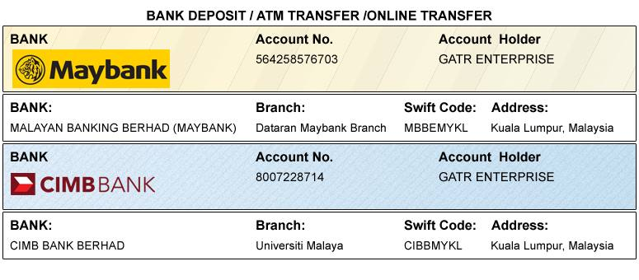
Option 1: Bank Deposit / ATM Transfer / Online Transfer / Foreign Telegraphic Transfer.

Option 2: PayPal / Credit Card / Debit Card:

Please visit: http://gcbss.org/cibssr2018/deans_&_directors_networking_session.html

PRIVACY POLICY:

The Global Academy of Training & Research (GATR) Division will protect your personal information. Your personal information received will only be used to fill your order. We will not sell or redistribute your information to anyone.

CANCELLATION POLICY:

You may cancel without penalty if written cancellation request are received up to and including 45 days prior to the start of the conference. A credit voucher less 50% of the registration fee will be issued for written requests received up to and including 25 days prior to the start of the conference. No refunds or credits will be issued on cancellation requests received less than 25 days prior to the start of the event. No liability is assumed by Global Conference on Business and Social Science for changes in program, date, content, speakers or venue.

PLEASE NOTE: Receipts will be provided on the Networking Session registration day (December 14, 2018) unless urgently required.

